Q1 wap to demonstrate ternary operator .define a variable marks .ask its value from user and using ternary operator check if marks > 40 store "Pass" in result varible else store "Fail"

package Assignment1;

import java.util.*;

public class a_ternaryoperator {

public static void main(String[] args) {

Scanner s1= new Scanner(System.in);

System.out.println("marks obtain");

int marks=s1.nextInt();

String result = (marks >40) ? "Pass" : "Fail";

System.out.println(result);}

}

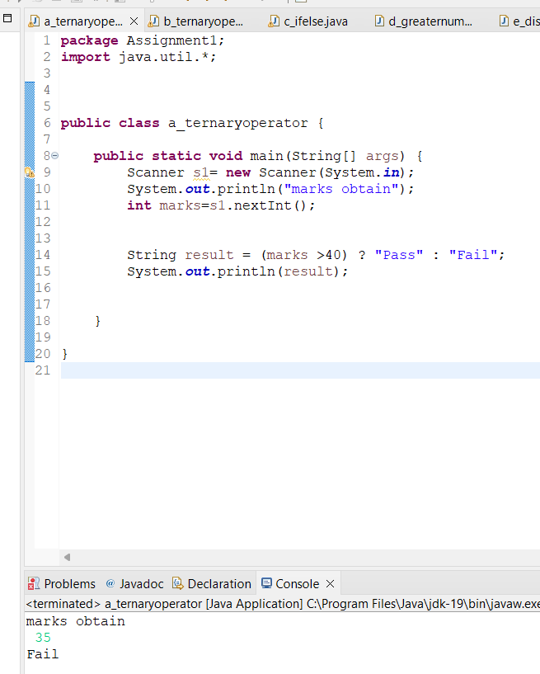

Q 2 using ternary check if number entered by user is positive or negative .

In case number is positive store "Positive number" else store negative number to Result variable

**package** Assignment1;

**import** java.util.*;

**public** **class** b_ternaryoperator {

**public** **static** **void** main(String[] args) {

Scanner s1= **new** Scanner(System.***in***);

System.***out***.print("Enter number :");

**int** num=s1.nextInt();

String result = num>0 ? "Positive number" : "Negative number";

System.***out***.print("This umber is "+result);

}

}

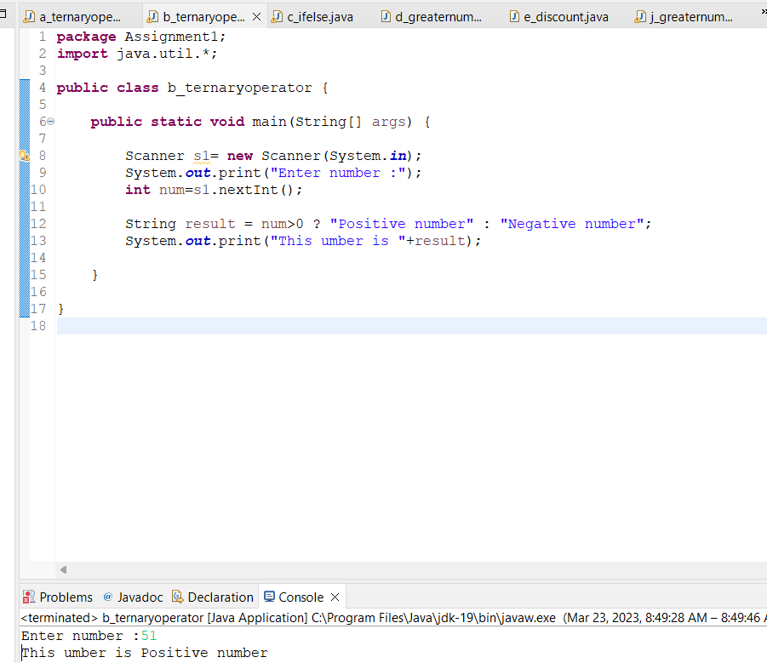

Q 3 WAP to ask name ,age and salary of an employee and print on console.

**package** Assignment1;

**import** java.util.*;

**public** **class** c_ifelse {

**public** **static** **void** main(String[] args) {

Scanner sc = **new** Scanner(System.***in***);

String name;

System.***out***.print("Enter name: ");

name = sc.nextLine();

**int** age;

System.***out***.print("Enter age: ");

age = sc.nextInt();

**double** salary;

System.***out***.print("Enter salary: ");

salary = sc.nextDouble();

System.***out***.println("Name: " + name);

System.***out***.println("Age: " + age);

System.***out***.println("Salary: " + salary);

}

}

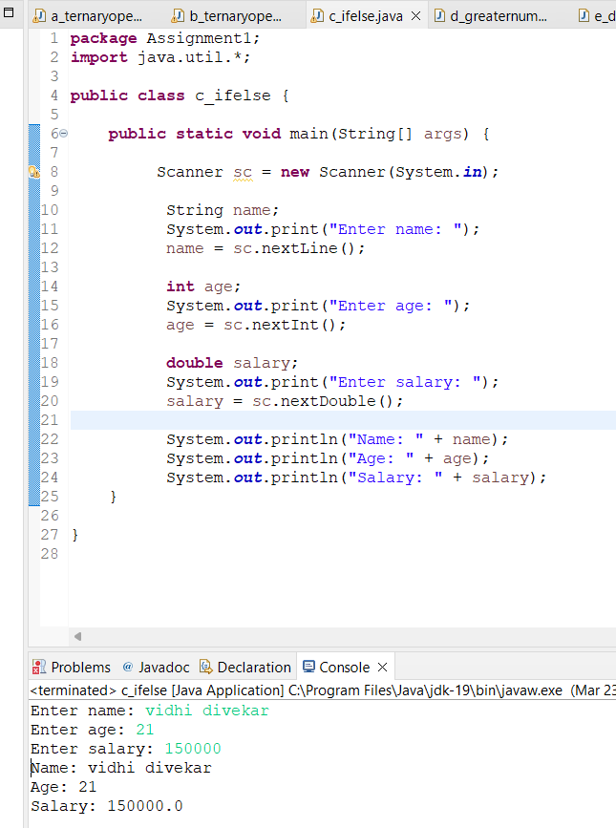

Q 4 wap  that ask two numbers from user and print greater number among two

**package** Assignment1;

**import** java.util.*;

**public** **class** d_greaternumber {

**public** **static** **void** main(String[] args) {

Scanner sc = **new** Scanner(System.***in***);

**int** num1;

System.***out***.print("Enter num1: ");

num1 = sc.nextInt();

**int** num2;

System.***out***.print("Enter num2: ");

num2 = sc.nextInt();

**if** (num1>num2)

System.***out***.println(num1);

**else**

System.***out***.println(num2);

}

}

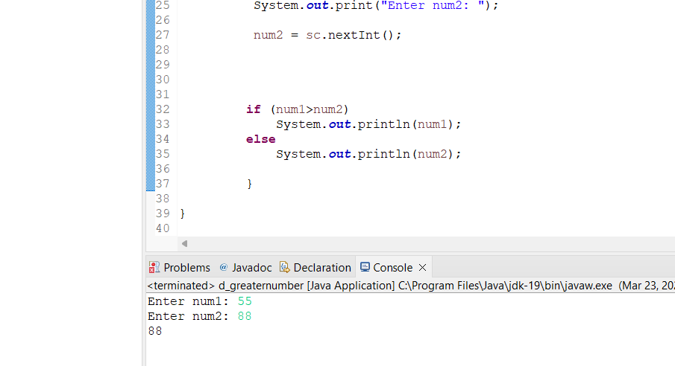

Q 5 wap to ask product name and price of product from user and calculate discount i.e   
if price > 2000 then discount is 10 percent of price   
else   
discount is 7 % of price

**package** Assignment1;

**import** java.util.*;

**public** **class** e_discount {

**public** **static** **void** main(String[] args) {

**try** (Scanner s = **new** Scanner(System.***in***)) {

{

**double** discount,finalprice;

String name;

System.***out***.print("Product name: ");

name = s.nextLine();

**int** num1;

System.***out***.print("Product price: ");

num1 = s.nextInt();

**if**(num1>=2000)

{

discount = 0.1 * num1;

}

**else**

{

discount = 0.07 * num1;

}

finalprice= num1-discount;

System.***out***.print("Discount on the product is"+discount);

}

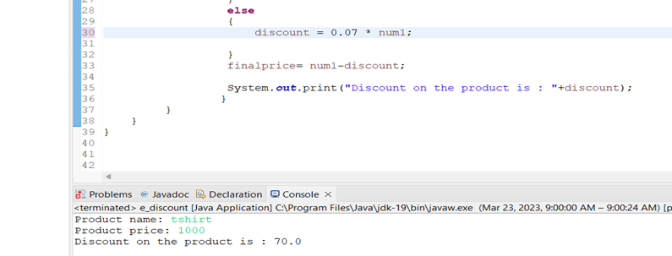 }

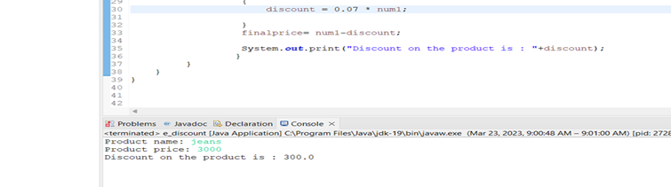

Q 6   Wap to swap two numbers

**package** Assignment1;

**public** **class** g_swap {

**public** **static** **void** main(String[] args) {

**int** a=25;

**int** b =50;

System.***out***.println("Before swap a was : "+a);

System.***out***.println("Before swap b was : "+b);

a = a+b; //15

b = a-b; //5

a = a-b; //10

System.***out***.println("After swap a became : "+a);

System.***out***.println("After swap b became : "+b);

}

}

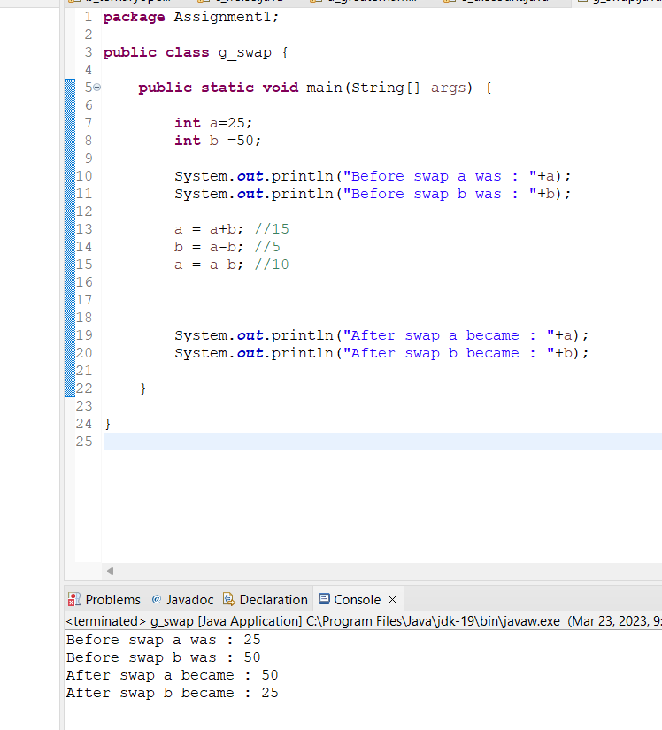

Q 7  How to swap two numbers without using a third variable?

**package** Assignment1;

**public** **class** f_swap2 {

**public** **static** **void** main(String[] args) {

{

**int** a = 5;

**int** b = 10;

System.***out***.println("Before swaping a :"+a);

System.***out***.println("Before swaping a :"+b);

**int** temp = a;

a = b;

b = temp;

System.***out***.println("After swaping a :"+a);

System.***out***.println("After swaping a :"+b);

}

}

}

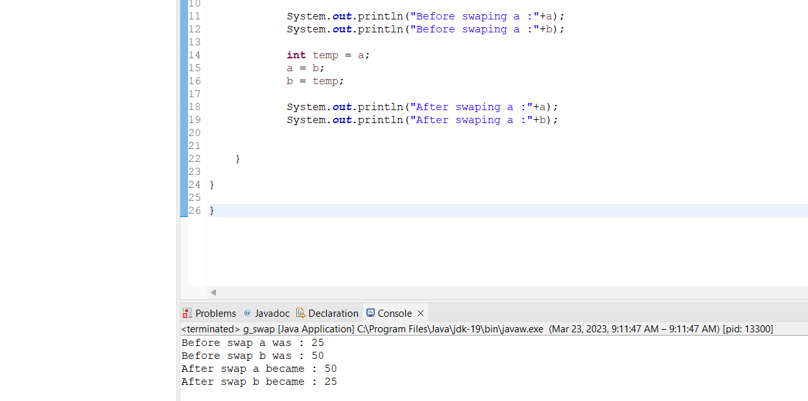

Q 8 wap to check is number is evenor odd.

**package** Assignment1;

**import** java.util.*;

**public** **class** h_evenorodd {

**public** **static** **void** main(String[] args) {

{

Scanner s = **new** Scanner(System.***in***);

System.***out***.print("Enter number :");

**int** num=s.nextInt();

**if**(num%2==0)

System.***out***.println("Number is even");

**else**

System.***out***.println("Number is odd");

}

}

}

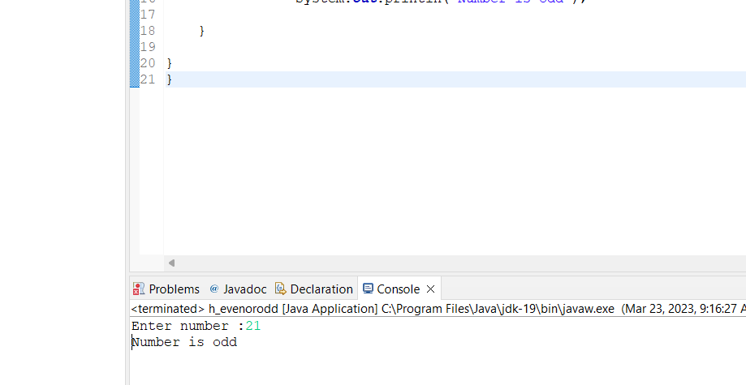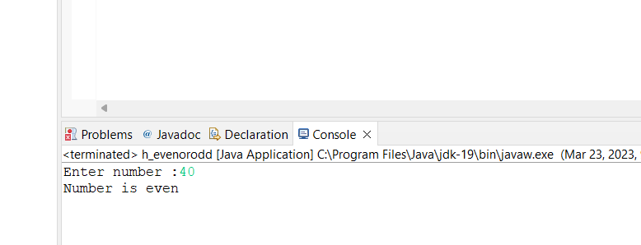

Q 9   A school has following rules for grading system:  
 a. Below 25 - F  
 b. 25 to 45 - E  
 c. 45 to 50 - D  
 d. 50 to 60 - C  
 e. 60 to 80 - B  
 f. Above 80 - A  
 Ask user to enter marks and print the corresponding grade

**package** Assignment1;

**import** java.util.*;

**public** **class** i_gradingsystem {

**public** **static** **void** main(String[] args) {

Scanner s1= **new** Scanner(System.***in***);

System.***out***.print("Enter number :");

**int** num=s1.nextInt();

**if**(num<25)

System.***out***.println("Grade : F");

**else** **if**(num<=45)

System.***out***.println("Grade : E");

**else** **if**(num<=50)

System.***out***.println("Grade : D");

**else** **if**(num<=60)

System.***out***.println("Grade : C");

**else** **if**(num<=80)

System.***out***.println("Grade : B");

**else** **if**(num<=100)

System.***out***.println("Grade : A");

}

}

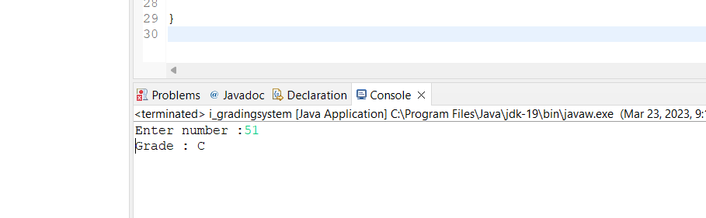

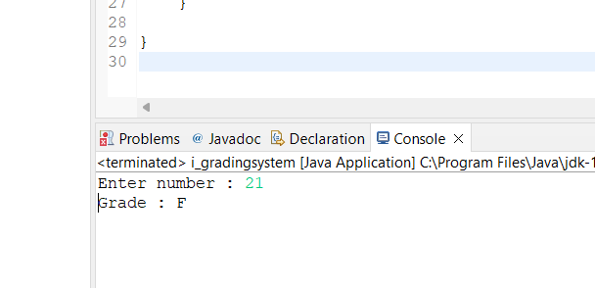

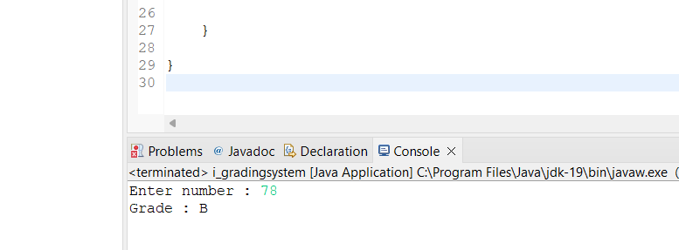

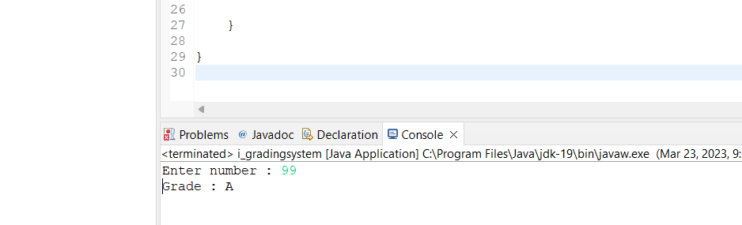

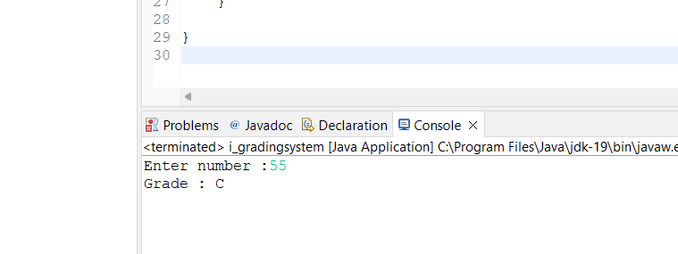

Q  10 wap to check greater number among three numbers

**package** Assignment1;

**import** java.util.*;

**public** **class** j_greaternumber {

**public** **static** **void** main(String[] args) {

{

Scanner s = **new** Scanner(System.***in***);

**int** num1;

System.***out***.print("Enter num1: ");

num1 = s.nextInt();

**int** num2;

System.***out***.print("Enter num2: ");

num2 = s.nextInt();

**int** num3;

System.***out***.print("Enter num3: ");

num3 = s.nextInt();

**int** result = (num1>num2) ? ((num1>num3)?num1:num3) : ((num2>num3)?num2:num3);

System.***out***.println("Greater number among this three number is : "+result);

}

}

}

